**DRIVING LICENCE TEST WEBSITE**

**ACKNOWLEDGEMENT**

We would like to thank the Principal of CMRCET, Dr. V. A. Narayana, for his support in the course of this project work.

We are obliged and grateful to thank MR.A. KOTISHWAR RAO Head (CEER), CMRCET,

for his cooperation in all respects during the course.

Finally, we thank all our faculty members and Lab Assistants for their valid support.

We own all our success to our beloved parents, whose vision, love and inspiration has made us reach out for these glories

**ABSTRACT**

In India major problem in the driving license system is the private intermediaries (“agents”) who will try to break the system to cash it. In order to avoid and arrest the malpractices of the corruption the use of technology and the software are used now. Our project is about creating website on driving license test. We are adding tutorial to the website which includes rules and regulations of driving, basic information about vehicles and traffic rules and mv acts violations and fines. After this tutorial next step is test. In this test we are going to give questions from the above tutorial information. If They pass the test they can go for direct license test. By our project people will get proper Idea and knowledge about driving, traffic rules and etc. Our website highlights how the new system eliminates the human interference and the subjectivity in the driving license testing system at all leve

**TABLE OF CONTENTS**

|  |  |  |  |
| --- | --- | --- | --- |
| **CHAPTERS** | | **DESCRIPTION** | **PAGE No** |
|  |  |  |  |
| 1 |  | Introduction | 7 |
| 2 | 2.1 | Problem Statement | 8 |
|  | 2.2 | Requirement analysis | 8-9 |
|  | 2.3 | Methodology | 9 |
| 3 | 3.1  3.2  3.3 | Definition  Working  Purpose | 10  10  11 |
| 4 | 4.1 | Existing solutions | 12-13 |
|  | 4.2 | Drawbacks | 13 |
| 5 | 5.1 | Implementation | 14-15 |
| 6 |  | Results and conclusions | 15-17 |
| 7 | 6.1  6.2  7.1  7.2  8.1 | Advantages  Disadvantages  Conclusion  Source code  References | 16  16  17  17-22  23 |

**CHAPTER 1**

**INTRODUCTION**

Driving may be a passion for many and a necessity to others. Whatever be the case, driving your own vehicle is a life skill which should be acquired. However, passing a driving test is a pre- requisite to obtaining a driving license and it is of extreme importance.

Like any academic course, after learning to drive, you would have to pass a practical and a theory test in order to obtain a license to drive a vehicle for every country. In India as well, you would require to pass a driving test in order to drive a vechile on the India roads according to the Motor Vehicles Act, 1988. No one will be allowed to drive a without a valid Driving license. Thus, if you wish to drive any, you should get a valid driving license.

Our website contains tutorials which includes rules and regulations of driving, basic information about vehicles and traffic rules. After this tutorials we are having test. In this test we are going to questions from the above tutorial information.If They pass the test they can go for direct license test.By our project people will get proper Idea and knowledge about driving, traffic rules and etc. Our website highlights how the new system eliminates the human interference and the subjectiv- ity in the driving license testing system at all levels.

**CHAPTER 2**

**2.1 PROBLEM STATEMENT**

The issue of Driving License is a major problem in developing countries mainly because of problems like lack of adequate manpower, infrastructure, testing facilities, backed by the weaknesses in the governance like lack of transparency, accountability, consistency etc. resulting corruption. The citizen’s willingness to pay for getting the driving License causes distortions in the system. In India major problem in the driving license system is the private intermediaries (“agents”) who will try to break the system to cash it. In order to avoid and arrest the malpractices of the corruption the use of technology and the software are used now. Our website highlights how the new system eliminates the human interference and the subjectivity in the driving license testing system at all levels

**2.2: REQUIREMENT ANALYSIS**

**HMTL**

The Hyper Text Markup Language or HTML is the standard markup language for documents designed to be displayed in a web browser. It can be assisted by technologies such as Cascading Style Sheets (CSS) and scripting languages such as JavaScript.

Web browsers receive HTML documents from a web server or from local storage and render the documents into multimedia web pages. HTML describes the structure of a web page semantically and originally included cues for the appearance of the document.

**CSS**

Cascading Style Sheets (CSS) is a style sheet language used for describing the presentation of a document written in a markup language such as HTML. CSS is a cornerstone technology of the World Wide Web, alongside HTML and JavaScript.

CSS is designed to enable the separation of presentation and content, including layout, colors, and fonts. This separation can improve content accessibility; provide more flexibility and control in the specification of presentation characteristics; enable multiple web pages to share formatting by specifying the relevant CSS in a separate. CSS file, which reduces complexity and repetition in the structural content; and enable the CSS file to be cached to improve the page load speed between the pages that share the file and its formatting.

**Bootstrap:**

Bootstrap is a free and open-source CSS framework directed at responsive, mobile-first front-end web development. It contains HTML, CSS and (optionally) JavaScript-based design templates for typography, forms, buttons, navigation, and other interface components.

**Logos:**

A logo is a symbol made up of text and images that identifies a business. A good logo shows what a company does and what the brand values.

Logo design is all about creating the perfect visual brand mark for a company. Depending on the type, a logo usually consists of a symbol or brandmark and a logotype, along with a tagline

**Google Images:**

Google Images is a web-based product by Google for searching for images online. While it performs the same basic querying and result-fetching functions as Google’s flagship search engine, it's better understood as a specialized offshoot.

**2.3 METHODOLOGY**

Driving license test website is designed in such a way that it consists tutorial which includes rules and regulations of driving, basic information about vehicles and traffic rules. After this tutorial next step is test. In this test questions are given from the above tutorial information.

**CHAPTER 3**

**3.1 DEFINITION**

Driving License is a major problem in developing countries mainly because of problems like lack of adequate manpower, infrastructure, testing facilities, backed by the weaknesses in the governance like lack of transparency, accountability, consistency etc. resulting corruption. The citizen’s willingness to pay for getting the driving License causes distortions in the system. In India major problem in the driving license system is the private intermediaries (“agents”) who will try to break the system to cash it. In order to avoid and arrest the malpractices of the corruption the use of technology and the software are used now.

**3.2 WORKING OF WEBSITE**

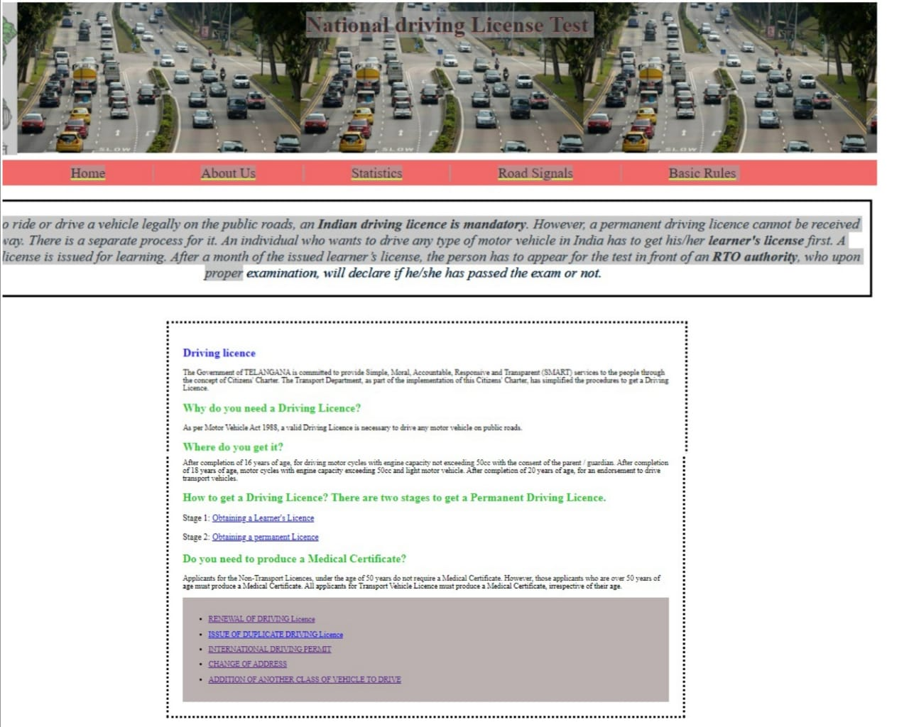

**3.3 PURPOSE OF WEBSITE**

The main purpose of the project is to create a website. In order to decrease, The issue of Driving License is a major problem in developing countries mainly because of problems like lack of adequate manpower, infrastructure, testing facilities, backed by the weaknesses in the governance like lack of transparency, accountability, consistency etc.

**CHAPTER 4**

**4.1 EXISTING SOLUTIONS**

**1.Driving schools**

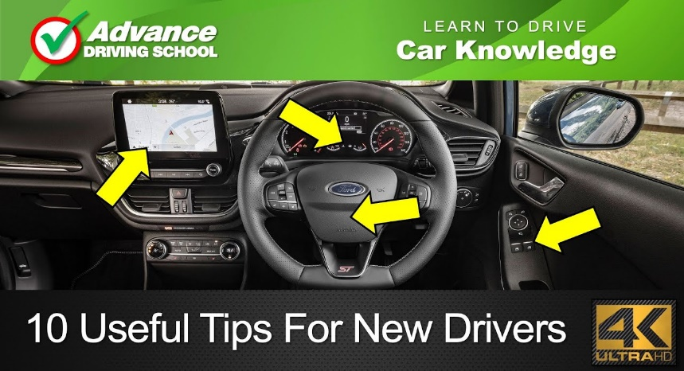

2.Websites:

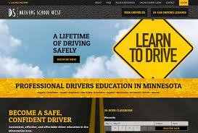

3.Apps:

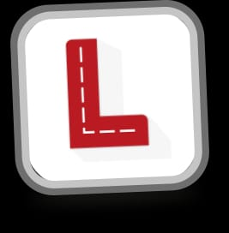

**4.2: DRAWBACKS OF EXISTING SOLUTIONS:**

* Technical issues
* Can't select the test language it is available only in English

**CHAPTER 5**

**5.1 IMPLEMENTATION**

Driving license test website is designed in such a way that it consists tutorial which includes rules and regulations of driving, basic information about vehicles and traffic rules. After this tutorial next step is test. In this test questions are given from the above tutorial information. The main aim of the website is people should get proper Idea and knowledge about driving, traffic rules and this website highlights how the new system eliminates the human interference and the subjectivity in the driving license testing system at all levels.

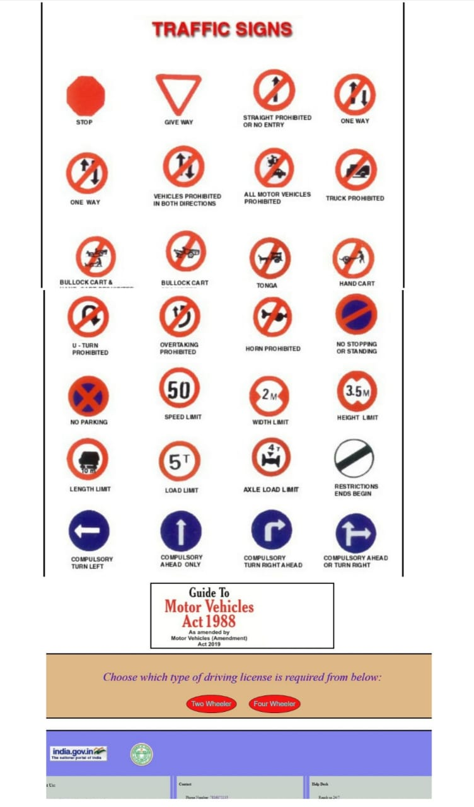

**CHAPTER 6**

**6.1 ADVANTAGES**

1. People get proper Idea and knowledge about traffic rules, road signals, driving etc.

2. Our website eliminates the human interference and the subjectivity in the driving license testing system.

**6.2 DISADVANTAGES**

1. Technical issues

2. Can't select the test language it is available only in English.

**CHAPTER 7**

**7.1 CONCLUSION**

The main aim of our driving license test website is people should get proper Idea and knowledge about driving, traffic rules and this website highlights how the new system eliminates the human interference and the subjectivity in the driving license testing system at all levels

**7.2 SOURCE CODE**

<!DOCTYPE html>

<html lang="en">

<head>

<meta charset="UTF-8">

<meta http-equiv="X-UA-Compatible" content="IE=edge">

<meta name="viewport" content="width=device-width, initial-scale=1.0">

<link rel="stylesheet" href="index.css">

<title>Driving Test</title>

</head>

<header>

<img style="padding-top: 10px; flex-grow:1;" src="./images/logo.png" alt="" width="50px;">

<h1 style="flex-grow: 9;">

National driving License Test</h1></header>

<nav class="navigation">

<a class="n1" href="index.html">Home</a>

<a class="n2" href="./aboutus.html">About Us</a>

<a class="n3" href="./statistics.html">Statistics</a>

<a class="n4" href="./roadSignals.html">Road Signals</a>

<a class="n5" href="./basicRules.html">Basic Rules</a>

</nav>

<body>

<div class="rules" style="margin-bottom:50px ;">

<p><i>In order to ride or drive a vehicle legally on the public roads, an <b>Indian driving licence is mandatory</b>. However, a permanent driving licence cannot be received right away. There is a separate process for it.

An individual who wants to drive any type of motor vehicle in India has to get his/her <b>learner's license</b> first. A learner’s license is issued for learning. After a month of the issued learner’s license, the person has to appear for the test in front of an <b>RTO authority</b>, who upon proper examination, will declare if he/she has passed the exam or not.</i></p>

</div>

<div class="driving-licence">

<h2 style="color:rgb(20, 20, 251) ;">Driving licence</h2>

<p>The Government of TELANGANA is committed to provide Simple, Moral, Accountable, Responsive and Transparent (SMART) services to the people through the concept of Citizens' Charter. The Transport Department, as part of the implementation of this Citizens' Charter, has simplified the procedures to get a Driving Licence.</p>

<h2 style="color:rgb(28, 199, 37) ;">Why do you need a Driving Licence?</h2>

<p>As per Motor Vehicle Act 1988, a valid Driving Licence is necessary to drive any motor vehicle on public roads.</p>

<h2 style="color:rgb(28, 199, 37) ;">Where do you get it?</h2>

<p>At the Regional Transport Office or Motor Vehicles Inspector's Office, having jurisdiction over your residential area.</p>

<h2 style="color:rgb(28, 199, 37) ;">When do you get it?</h2>

<p>After completion of 16 years of age, for driving motor cycles with engine capacity not exceeding 50cc with the consent of the parent / guardian. After completion of 18 years of age, motor cycles with engine capacity exceeding 50cc and light motor vehicle. After completion of 20 years of age, for an endorsement to drive transport vehicles.</p>

<h2 style="color:rgb(28, 199, 37) ;">How to get a Driving Licence? There are two stages to get a Permanent Driving Licence.</h2>

<p style="font-size:large ;">Stage 1: <a style=" font-size: large;" href="stage1.html">Obtaining a Learner's Licence</a></p>

<p style="font-size:large ;">Stage 2: <a style="font-size:large ;" href="stage2.html">Obtaining a permanent Licence</a></p>

<h2 style="color:rgb(28, 199, 37) ;">Do you need to produce a Medical Certificate?</h2>

<p>Applicants for the Non-Transport Licences, under the age of 50 years do not require a Medical Certificate. However, those applicants who are over 50 years of age must produce a Medical Certificate. All applicants for Transport Vehicle Licence must produce a Medical Certificate, irrespective of their age.</p>

<div style="background-color:rgb(187, 177, 177) ; padding: 15px; line-height: 2;">

<ul>

<li><a href="renewal.html">RENEWAL OF DRIVING Licence</a></li>

<li><a href="issueDuplicate.html">ISSUE OF DUPLICATE DRIVING Licence</a></li>

<li><a href="internationalDrivingPermit.html">INTERNATIONAL DRIVING PERMIT</a></li>

<li><a href="changeofAddress.html">CHANGE OF ADDRESS</a></li>

<li><a href="additionOfanotherClass.html">ADDITION OF ANOTHER CLASS OF VEHICLE TO DRIVE</a></li>

</ul>

</div>

</div>

<div >

<img style="margin-left: 26%; border-style:solid; padding: 20px; margin-top: 20px; " src="./images/signs.jpg" alt="Sorry image cannot be loaded" width="50%" height="40%">

</div>

<div style="margin-left:30% ; border-style:solid; margin-right:30%; margin-top:30px;">

<a href="./MV ACT.pdf" target="_blank"><img src="./images/mv act.jpg" alt="Sorry pdf cannot be loaded" width="500px"></a>

</div>

<div class="btn">

<p class="choose"><i>Choose which type of driving license is required from below:</i></p>

<button class="btn1"><a class="blink1" style="text-decoration:none; color:aqua ;" href="twoWheeler.html">Two Wheeler</a></button>

<button class="btn2"><a class="blink2" style="text-decoration:none; color:aqua ;" href="fourWheeler.html">Four Wheeler</a></button>

</div>

</body>

<footer>

<div style="margin-bottom:30px ;" class="logos">

<a style="margin-right:100px ; margin-left:80px; margin-top:15px;" href="https://www.india.gov.in/"><img src="./images/indlogo.jpg" alt="Sorry logo cannot be loaded" width="250px"> </a>

<a href="https://www.telangana.gov.in/"><img src="./images/telanganalogo.png" alt="Sorry logo cannot be loaded" width="100px"></a>

</div>

<div class="fo">

<div style="flex-grow:1 ;" class="1">

<p style="font-size:larger ;"><b>About Us:</b></p>

<div style="margin-left:20px ;">

<p>The main objective of the website is people </p>

<p> should get proper Idea and knowledge about </p>

<p>driving, traffic rules and acts etc and this </p>

<p>website highlights how the new system eliminates </p>

<p>the human interference and the subjectivity in the </p>

<p>driving license testing system at all levels.</p>

</div>

</div>

<hr>

<div style="margin-left:15px ; flex-grow:1;" class="2">

<p><b>Contact</b></p>

<div style="margin-left: 20px;">

<p>Phone Number: <a href="">7816071135</a></p>

<p>Landline: <a href="">8712255105</a></p>

<p style="line-height:1.5 ;">Write us at: <a href="">20H51A04C6@cmrcet.ac.in</a> or </p>

<p><a href="">20H51A04H9@cmrcet.ac.in</a></p>

</div>

</div>

<hr>

<div style="margin-left:15px ;flex-grow:1;" class="3">

<p><b>Help Desk</b></p>

<div style="margin-left:20px ;">

<p>Reach us 24/7</p>

<p>For ny Quiries reach our help desk and seek help </p>

<p>from the customer care and get your problems solved</p>

<p>Our help desk is available 24/7</p>

</div>

</div>

</div>

<hr>

<div class="tags">

&nbsp;&nbsp;&nbsp;&nbsp;&nbsp;&nbsp;&nbsp;&nbsp;&nbsp;&nbsp;&nbsp;&nbsp;&nbsp;&nbsp;&nbsp;&nbsp;&nbsp;&nbsp;&nbsp;&nbsp;&nbsp;&nbsp;&nbsp;&nbsp;&nbsp;&nbsp;&nbsp;&nbsp;&nbsp;&nbsp;&nbsp;&nbsp;&nbsp;

<p style="flex-grow:2 ;">Privacy Policy</p>

<p style="flex-grow:2 ;">Terms</p>

<p style="flex-grow:2 ;">Copyright © 2022 Team 3</p>

**CHAPTER 8**

**8.1 REFERENCES**

1. <https://www.transport.telangana.gov.in/>

2. <https://vahan.nic.in/nrservices/>